[**Making an MMO in 48 Hours**](https://0fps.net/2012/04/24/making-an-mmo-in-48-hours/)

Posted on [April 24, 2012](https://0fps.net/2012/04/24/making-an-mmo-in-48-hours/)by [mikolalysenko](https://0fps.net/author/mikolalysenko/)

Ludum Dare 23 is done, and[**here are my results**](http://www.ludumdare.com/compo/ludum-dare-23/?action=preview&uid=5670):

[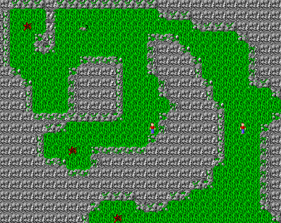](http://www.ludumdare.com/compo/ludum-dare-23/?action=preview&uid=5670)

I really doubt that I am going to win any awards for graphics…  or gameplay… or sound..   BUT!

* It is multiplayer
* It has persistent state
* It is HTML5
* And it actually works!

How cool is that?  Pretty amazing what you can do in a weekend.  I’m not sure if this is the first successfully completed MMO made for Ludum Dare, but I daresay that it is not something which is frequently attempted (possibly with good reason).  The tools I used to create this monstrosity were [node.js](http://nodejs.org/), [mongodb](http://www.mongodb.org/) and [crafty](http://craftyjs.com/).  In terms of development, here is what went right:

* Node.JS is a fantastic platform for making multiplayer games.  Event driven concurrency is basically the model most games use anyway, and I have yet to see any system which does this better.
* Even though it would not be my first choice of language, if you are doing web programming you are stuck using javascript.  Being able to use the same language on the server (and share code) is a huge advantage.  The result was I didn’t have to write, debug and maintain two different versions of A-star while doing the development.
* MongoDB is also quite a nice tool for game programming.  While in most situations I would say the lack of a structured column format is a disadvantage, it actually turns out to be a real help for gamedev and rapid prototyping.  In particular, it was very convenient to make a table with player stats and just keep adding fields to it while developing without worrying about it.  Of course you could probably get similar results by just making a raw string column in a SQL table, but this is a bit ugly and does not integrate as well with node.js.
* [Nodejitsu](http://nodejitsu.com/) is a very nice host.  Nuno Job graciously offered me a coupon earlier, and I have to say I was very impressed with their service.  Compared to nodester, one of their best features is the automatic database set up and configuration.
* Making a click based system for navigation is a cheesy way to handle latency, but it works.

Now for what went wrong:

* Unfortunately, I was not very disciplined with the amount of time I spent programming.  For me coding stuff is the most fun, and I tend to procrastinate on the drawing side of things.  As a result, the graphics in the game look pretty terrible.  The grass texture in particular turned out eye-bleedingly bad 😦
* The other consequence of over indulging in coding was that I didn’t spend much time on the game itself.  There is really only one type of enemy (a rat), and not much to do in the game besides kill people.  The map is also very empty/boring.  (Though there is a boss battle/final secret.)
* No sound
* This was my first time using crafty.js, which I selected using the “deliberative” method of random google search for “HTML 5 game engine”.  As a result, I spent some time up front trying to figure out how to get everything working.  Crafty itself seems like a fine piece of technology, but the documentation and examples really need some work.  In particular the “RPG tutorial” is out of date and doesn’t work with the latest version.  This cost me maybe 2-3 hours trying to get it to work, which I would say was the low point of the whole competition.  In the end I just gave up with the docs and read the source code directly, which turned out to be much easier to understand.  However, despite this setback, using crafty was still a net savings over doing everything from scratch, especially taking into account debugging and portability issues.

In the end, I had a lot of fun making this (although the final game is kind of terrible).  Once again, if you want to give it a try here is the link:

[**http://ludumdare23.nodejitsu.com/**](http://ludumdare23.nodejitsu.com/)